# **Introduction**

It will be an online e-commerce shopping platform for the buyers and sellers of clothing brands. It will help buyers to shop from a single platform instead of going here and there. It will gather all the brands from where people can buy their products by applying different filters of price, color, brands, etc. It will make online shopping much easier for the customers.

## Motivations

This is the era of technology, everyone is trying to provide the best online platforms, especially in the situations like COVID. In this situation, everybody switches to online shopping, online study, and online business. The use of online platforms is much increased nowadays. People feel it easy to shop online rather than roaming here and there. This online platform will help people shop online and shop for different clothing brands from a single platform.

## Project Overview

It will be an online e-commerce platform from which users can buy products from their favorite clothing brands on a single platform. It will make shopping easier for customers who prefer online shopping.

### Problems/ Overview

People are busy in their lives, they don’t have enough time to go and visit every outlet one by one. And it is also a hassle to visit every online store. So to overcome this issue we are making this project.

### Customer

There will be two types of customers on this platform. One will be the buyer who wants to purchase products. And another one is the seller which will sell his products on this platform.

### Goals

We aim to cater to a maximum audience. We aim to save our audience time and increase the business by providing a single platform with multiple functionalities.

### System Functions

* The system shall be able to allow users to place orders for delivery.
* The system shall be able to allow users to add products to the cart.
* The system shall be able to allow users to search for products and brands.
* The system shall be able to allow users to apply filters.
* The system shall be able to show related products to the buyer.

### System Attributes

* The system shall be available 24/7.
* The system will be responsive, it will be able to adapt the interface according to the device on which it is being used.
* The system shall not be able to allow unauthorized access.
* The system shall be able to handle the traffic.
* The system shall be able to load the main page in a few seconds after opening.

## Problem Statement

The problem which we are making this project is that it is difficult and time-consuming to go to every web page and visit them all one by one. Ifthere is a single platform that can display all products and users will be able to shop everything from there. It will be helpful. On the other hand, some small businesses which cannot afford their websites can all add their data here and sell their products online.

## Objectives

It will save time because buyers don’t have to physically go to the market to buy products. Instead, they can buy their products anytimeand anywhere. It will also grow and promote online business. It will provide ease by having all brands in one place so that buyers do not have to go to different websites.

# **Domain Analysis**

## Customer

This project is not for a specific client. Nor it is a contracted project. It is a self-based project.

## Stakeholders

Here is the list of all the stakeholders taking part in this project

Table.2.2.1: List of Stakeholders

|  |  |
| --- | --- |
| **Stakeholder** | **Role in System** |
| Buyers | They are responsible for viewing and buying products related to their choice. |
| Sellers/ Brands | They are responsible for managing orders and delivering orders at the doorstep. They are also responsible for managing and updating products. |
| Admin | He is responsible for the whole system. He is responsible for accounts and all the issues related to the website. |

## Affected Groups With Social and Economic Impact

Here are the groups who are impacted by this system:

* **Buyers**

It will provide great benefit to the buyer who wants to purchase any product related to clothing. He/ She can easily view all products of all brands on one platform.

* **Sellers/ Brands**

It will also provide great benefit to the seller who wants to sell products. It will increase the sale of their products and will allow the business to grow fast.

## Dependencies

This project depends on these components for its completion.

* Easy Paisa
* Jazz Cash
* Visa/ Master Cards

## Reference Documents

IEEE Recommended Practice for Software Requirement Specifications.

### Related Projects

Here are some projects related to this project which we looked up as reference material.

1. **Daraz.pk**

It includes clothing, shoes, accessories, bags, jewelry, and all the products of all the brands across the globe. Its CEO is Bjarke Mikklesen.

<https://www.daraz.pk/>

1. **Goto.com.pk**

It includes a wide range of brands and products including technology, fashion, beauty, and lifestyle. Its CEO is Asadullah Khan.

<https://goto.com.pk/>

1. **Shopon.pk**

It includes apparel, accessories, and electronics of different brands. Its CEO is Usman Sheikh.

<https://shopon.pk/>

### Feature Comparison

Table2.5.2.1: Feature Comparison

|  |  |  |  |  |  |
| --- | --- | --- | --- | --- | --- |
| **Sr. no** | **Comparison Features** | **Daraz** | **Goto** | **Shopon** | **Better To Buy (Our project)** |
| 1 | Price Comparison | No price comparison feature | No price comparison feature | No price comparison feature | Price comparison helps the buyers to compare the prices of selected products on different web pages. |
| 2 | Find in store | No find in store feature | No find in store feature | No find in store feature | Find in-store helps the buyer to search stores. |
| 3 | Search | Search helps the user to find whatever product he/she wants. | Search helps the user to find whatever product he/she wants. | Search helps the user to find whatever product he/she wants. | Search helps the user to find whatever product he/she wants. |
| 4 | Filter | No filter feature. | The filter will help buyers to choose products according to their choice. | No filter feature. | The filter will help buyers to choose products according to their choice. For example brands, price, and color. |

# **Requirement Analysis**

## Requirements

The requirements are based on what features or qualities the system requires to perform its tasks. Following is the table of requirement categories so it is easier for the user to identify the requirement type.

Table 3.1.1: Requirement Categories

|  |  |  |
| --- | --- | --- |
| **RID** | **Requirement Type** | **Description** |
| FR 1 | Functional Requirements | The core requirements of any business feature. |
| NFR 2 | Non Functional Requirements | These are supporting requirements but not as necessary as functional requirements. |
| PR 3 | Programming Requirements | These define the tools that are used in development. |
| DR 4 | Data Requirements | This tells how the users will store data. |

## List of Requirements

The following table consists of the requirements that are needed for this project.

Table 3.2.1: Requirements Table

|  |  |  |  |  |
| --- | --- | --- | --- | --- |
| **RID** | **Description** | **Category** | **Attribute** | **Details & Boundary Constraints** |
| FR 1.1 | The user shall be able to sign up. | Functional Requirement | Sign up Interface | * Enter email. * Enter phone number. * Enter username. * Enter password. * Enter store name. |
| FR 1.2 | The user shall be able to sign in. | Functional Requirement | Sign In Interface | * Enter username. * Enter password. |
| FR 1.3 | The user shall be able to update store. | Functional Requirement | Seller Dashboard | * Change categories. * Add discount. |
| FR 1.4 | The user shall be able to manage store. | Functional Requirement | Seller Dashborad | * Edit products. * Edit orders. * Edit payments. |
| FR 1.5 | The user shall be able to manage delivery of orders. | Functional Requirement | Order list in Seller Dashboard. | * View orders. * Edit orders. * Delete orders. |
| FR 1.6 | The user shall be able to view order status. | Functional Requirement | Pending orders page in Seller Dashboard. | * View pending orders. * View delivered orders. |
| FR 1.7 | The system shall be able to show that the product is out of stock. | Functional Requirement | Product Description. | * View product availability status. |
| FR 1.8 | The user shall be able to give discount on the products. | Functional Requirement | Products Page. | * Add discount. * Remove discount. * Edit discount. |
| FR 1.9 | The user shall be able to view buyers detail. | Functional Requirement | Customers detail in order page. | * View customer name. * View customer email. * View customer phone number. * View customer address. |
| FR 1.10 | The user shall be able to generate bill. | Functional Requirement | Billing page. | * View bill * Print bill. |
| FR 1.11 | The user shall be able to view payment method. | Functional Requirement | Checkout page. | * View payment method. * View payment details. |
| FR 1.12 | The system shall be able to show products on screen. | Functional Requirement | Main page. | * View products. |
| FR 1.13 | The user shall be able to select product. | Functional Requirement | Main page. | * View product description. * Select quantity of product. |
| FR 1.14 | The system shall be able to show categories. | Functional Requirement | Main page. | * View categories. * Open category. |
| FR 1.15 | The user shall be able to search product or store. | Functional Requirement | Search bar. | * Enter product name. * Enter shop name. |
| FR 1.16 | The system shall be able to show products of any specific brand. | Functional Requirement | Brands Filter. | * Apply filter to brand name. * Remove filter. |
| FR 1.17 | The system shall be able to show products of a specific color. | Functional Requirement | Color Filter. | * Apply color filter. * Remove filter. |
| FR 1.18 | The system shall be able to show products of specific price. | Functional Requirement | Price Filter. | * Apply price filter. * Remove filter. |
| FR 1.19 | The user shall be able to add product to cart. | Functional Requirement | Shopping Cart. | * Add product to cart. * Remove product from cart. * Select quantity of product. |
| FR 1.20 | The system shall be able to show the products added to cart. | Functional Requirement | Shopping Cart. | * Add product. * Delete product. * Update quantity of product. |
| FR 1.21 | The user shall be able to place order. | Functional Requirement | Checkout Page. | * Enter delivery details. |
| FR 1.22 | The user shall be able to pay through debit card. | Functional Requirement | Payment Method. | * Select method of payment. |
| FR 1.23 | The user shall be able to pay cash on delivery. | Functional Requirement | Payment Method. | * Select cash on delivery method. |
| FR 1.24 | The system shall be able to allow admin to login to the system. | Functional Requirement | Admin Panel. | * Enter admin name. * Enter admin password. |
| NFR 2.1 | Availability of system. | Non-Functional Requirement | Online System. | * The system shall be available 24/7. |
| NFR 2.2 | Integrity of system. | Non-Functional Requirement | User Interface. | * The system shall be protected from unauthorized access. |
| NFR 2.3 | Performance of system. | Non-Functional Requirement | User Interface. | * The system shall be able to respond quickly. |
| NFR 2.4 | Reliability of system. | Non-Functional Requirement | Online System. | * The system shall overcome failures quickly. |
| NFR 2.5 | Usability of system. | Non-Functional Requirement | User Interface. | * The user shall be able to use it in no time. |
| NFR 2.6 | Efficiency of system. | Non-Functional Requirement | Online system. | * The system shall be able to load in just 3 seconds. |
| NFR 2.7 | Responsiveness of system. | Non-Functional Requirement | User Interface. | * The system shall be able to work on all types and all sizes of screen. |
| NFR 2.8 | Portability of system. | Non-Functional Requirement | User Interface. | * The system shall be able to work on Chrome, Mozilla, Microsoft Edge etc. |
| NFR 2.9 | Correctness of the system. | Non-Functional Requirement | Online System. | * The system shall be able to perform all its functionalities correctly. |
| PR 3.1 | Web Development Tools. | Programming Requirements. | Developing Site. | * Windows OS. * Visual Studio Code. * React Framework. * MUI. * Strapi. |
| DR 4.1 | Data Storage. | Data Requirements. | Storage Resource. | * Postgres DB. |

## List of Actors

* **Admin:** The person who is handling and managing the whole system.
* **Sellers:** The persons (Shops/ Stores) who want to sell their products through this platform.
* **Buyers:** The persons who are busy and have no time to go to every shop. They want their orders to be received at their doorstep.

## List of Use cases

List of use cases with description are given below:

* **UC-01 Sign Up:** Allow users to provide account information and get access to the services.
* **UC-02 Sign In:** Allow user to login to their account.
* **UC-03 Select Product:** Allow user to select product he/she wants to buy.
* **UC-04 Add to Cart:** Allow user to add products of their choice to the cart.
* **UC-05 Checkout:** Allow userto enter address and billing information for order processing.
* **UC-06 View Cart:** Allow user to view recently added products in cart.
* **UC-07 Search Product:** Allow user to search product of his/her choice.
* **UC-08 Search Shop:** Allow user to search shop/ store of his choice.
* **UC-09Apply Filters:**Allow users to apply filter to find products of certain price, brand, and color.
* **UC-10 Place Order:**Allow user to place order of products added to cart.
* **UC-11 Make Payment:**Allow user to make payment of placed order.
* **UC-12 View Orders:** Allow user to view his/her order.
* **UC-13 View Order Status:** Allow user to check the status of order.
* **UC-14 Add Product:**Allow user to add product.
* **UC-15 View Product:**Allow user to view product.
* **UC-16 Delete Product:**Allow user to delete product.
* **UC-17View Sold Items:**Allow user to view products that are sold.
* **UC-18 Add Discount:**Allow user to add discount to the products.
* **UC-19 View Vendor:**Allow user to view vendors on the website.
* **UC-20 Delete Vendor:**Allow user to delete the vendor.
* **UC-21 Add Category:**Allow user to add a new category.
* **UC-22 Edit Category:**Allow user to edit category to add or change something.
* **UC-23 Delete Category:**Allow user to delete category that is not in use.
* **UC-24 View Category:** Allow user to view all the categories present in that system.

## System Usecase Diagram

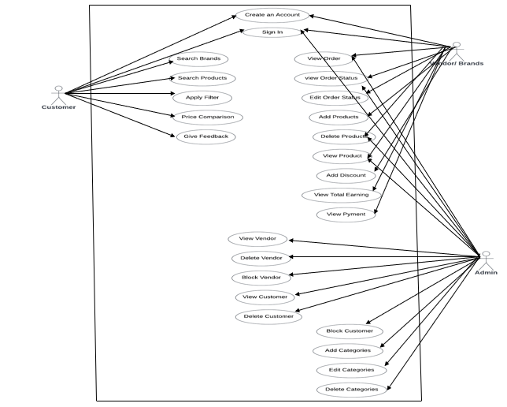

Figure 3.5.1: Usecase Diagram

## Use Cases

Table 3.6.1: UC-01 Sign Up

|  |  |  |  |
| --- | --- | --- | --- |
| **Use Case ID:** | UC-01 | | |
| **Use Case Name:** | Sign Up | | |
| **Created By:** | Zuha Urooj | **Last Updated By:** | Zuha Urooj |
| **Date Created:** | 10 June, 2022. | **Last Revision Date:** | 12 June, 2022. |
| **Actors:** | Admin, Vendor/ Seller/ Shop, Buyer | | |
| **Description:** | The Customer entered the asked details by system to create an account for purchasing and selling of products. The system will create purchase account if he/she is customer and seller account if he/she is seller/ vendor. | | |
| **Trigger:** | Customer or Vendor/ Seller indicate that he/ she wants to create an account. | | |
| **Preconditions:** | 1. Customer or Vendor/ Seller must have email id. 2. Customer or Vendor/ Seller must be aware of using websites. | | |
| **Post conditions:** | 1. Request for create an account is stored in system. 2. System display message: Signed In successfully. | | |
| **Normal Flow:** | **Create account for customer or vendor/ seller**   1. Customer click on join button to open page to register as customer or on sell button to open to register as seller/ vendor. 2. System show the sign in page. 3. Customer enter the asked details by system for creation of account. 4. Customer then click on sign up button. 5. System will create an account and display message: Signed In successfully. | | |
| **Alternative Flows:** | **Create account using Gmail**   1. Customer click on join button to open page to register as customer or on sell button to open to register as seller/ vendor. 2. System show the register page. 3. Customer then click on Google+ button. 4. System will create an account and display message: Signed In successfully. | | |
| **Exceptions:** | **01.3 Email is already in use by another person**   1. System displays message: Email is already used by some other user. 2. System ask customer if he/ she want to enter another email. 3. Customer enter another email. 4. System start normal flow. | | |
| **Priority** | High | | |
| **Frequency of Use:** | Approximately 10 to 15 times per day by each customer. | | |
| **Special Requirements:** | 1. The System shall be able to create an account for the customer or vendor/ seller in less than 10 sec. | | |
| **Assumptions:** | 1. The Customer have little knowledge of system. 2. Customer have an active email id. | | |
| **Notes and Issues:** | System will not create an account if customer or vendor/ seller entered the email which is already in used by another user. | | |

Table 3.6.2: UC-02 Sign In

|  |  |  |  |
| --- | --- | --- | --- |
| **Use Case ID:** | UC-02 | | |
| **Use Case Name:** | Sign In | | |
| **Created By:** | Zuha Urooj | **Last Updated By:** | Zuha Urooj |
| **Date Created:** | 10 June, 2022. | **Last Revision Date:** | 12 June, 2022. |
| **Actors:** | Customer, Vendor/ Seller/ Shop and Admin | | |
| **Description:** | The Customer entered the valid email address and password or used Google+ or Facebook to Sign In into account. The system will check for authentication and allow user to enter into account. | | |
| **Trigger:** | Customer or Vendor/ Seller indicate that he/ she wants to Sign In into account. | | |
| **Preconditions:** | 1. Customer, Vendor/ Seller or Admin must have an account. 2. Customer or Vendor/ Seller must be on the Sign In page. | | |
| **Post conditions:** | 1. Request for Sign In into account is stored in system. 2. System will check for authentication. | | |
| **Normal Flow:** | **Sign In into account**   1. Customer click on Sign In button to open page to Sign In into account. 2. System show the Sign In page. 3. Customer enter the valid email address. 4. Customer then enter the valid password. 5. Customer then click on the login button. 6. System will check for an authentication. | | |
| **Alternative Flows:** | **Sign In using Google**   1. Customer click on Sign In button to open page to Sign In into account. 2. System show the Sign In page. 3. Customer then click on Google+ or Facebook button. 4. System will check for an authentication. | | |
| **Exceptions:** | **Entered wrong Password**   1. System displays message: Information Does Not Match. 2. System ask customer if he/ she want to enter password again. 3. Customer again enter password. 4. System start normal flow. | | |
| **Priority** | High | | |
| **Frequency of Use:** | Approximately 10 to 15 times per day by each customer. | | |
| **Special Requirements:** | 1. The System shall be able Sign In into account just in 2 sec. | | |
| **Assumptions:** | 1. The Customer have little knowledge of system. 2. Customer have an active email id. 3. Customer have an account. | | |
| **Notes and Issues:** | System will not Sign In into account if customer, vendor/ seller, admin entered the email address or password. | | |

Table 3.6.3: UC-03 Select Product

|  |  |  |  |
| --- | --- | --- | --- |
| **Use Case ID:** | UC-03 | | |
| **Use Case Name:** | Select Product | | |
| **Created By:** | Anam Asghar | **Last Updated By:** | Anam Asghar |
| **Date Created:** | 13 May, 2022. | **Last Revision Date:** | 13 May, 2022. |
| **Actors:** | Vendor/ Seller/ Shop/ Customer | | |
| **Description:** | The Vendor/ Seller/ Shop/ Customer selects the Product name of which he/ she wants to view in the system. The system will view that product from the product list. | | |
| **Trigger:** | Vendor/ Seller/ Shop/ Customer indicates that he/ she wants to view category. | | |
| **Preconditions:** | 1. Vendor/ Seller/ Customer must have an account. 2. Vendor/ Seller/ Customer must be Sign In into account. 3. Vendor/ Seller/ Customer must be on Product Page. | | |
| **Post conditions:** | 1. Request for select Product is stored in system. 2. System will select the Product from the Product list. | | |
| **Normal Flow:** | **Select Product**  1. Vendor/ Seller/ Shop/ Customer click on Product dropdown link.  2. Vendor/ Seller/ Shop/ Customer again click on View Product.  3. System display the Products page.  4. System views the Product from the Product list. | | |
| **Alternative Flows:** | **Select Product from the Product list.**  1. Vendor/ Seller/ Shop/ Customer click on Product dropdown link.  2. System show the drop-down menu.  3. Vendor/ Seller/ Shop/ Customer again click on All Product link.  4. System display the list of all Products.  5. Vendor/ Seller/ Shop/ Customer click on Product.  6. System selects the Product from the Product list. | | |
| **Exceptions:** | N/A | | |
| **Priority** | High | | |
| **Frequency of Use:** | Approximately 40 to 50 times in a day by Vendor/ Seller/ Shop. | | |
| **Special Requirements:** | A Product shall be selected from product list in less than 2 sec. | | |
| **Assumptions:** | 1. The Vendor/ Seller/ Shop/ Customer have little knowledge of system. 2. The Vendor/ Seller/ Shop/ Customer has an account. 3. The Vendor/ Seller/ Shop/ Customer has Sign In into account. | | |
| **Notes and Issues:** | System will not select Product unless the Product already exists in Product list. | | |

Table 3.6.4: UC-26 Add to Cart

|  |  |  |  |
| --- | --- | --- | --- |
| **Use Case ID:** | UC-26 | | |
| **Use Case Name:** | Add to Cart | | |
| **Created By:** | Anam Asghar | **Last Updated By:** | Anam Asghar |
| **Date Created:** | 13 May, 2022. | **Last Revision Date:** | 13 May, 2022. |
| **Actors:** | Customer. | | |
| **Description:** | The Customer adds the product to cart which he/ she want to purchase. The system will add that product to the cart. | | |
| **Trigger:** | Customer indicates that he/ she wants to add product to cart. | | |
| **Preconditions:** | 1. Customer must have selected product. 2. Customer must be on the right page. 3. Vendor must have product in product list. | | |
| **Post conditions:** | 1. Request for add to cart on product is stored in system. 2. System will add to the cart. | | |
| **Normal Flow:** | **Add to Cart**   1. Customer click on Products dropdown link. 2. System show the drop-down menu. 3. Customer click on All Products link. 4. System display the list of all products. 5. Customer select the Product on which he/she wants to buy. 6. Customer then click on Add to Cart button. 7. System display the Added to Cart message. 8. System update and add the product to cart. | | |
| **Alternative Flows:** | N/A | | |
| **Exceptions:** | N/A | | |
| **Priority** | High | | |
| **Frequency of Use:** | Approximately 50 to 60 times per day. | | |
| **Special Requirements:** | 1. The System shall be able to add product to cart just in 1 sec. | | |
| **Assumptions:** | 1. The customer have little knowledge of system. 2. The customer has an account. 3. The customer has Sign In into account. 4. The customer has already added the product. | | |
| **Notes and Issues:** | System will not add the product to cart if it is out of stock. | | |

Table 3.6.5: UC-09 Place an Order

|  |  |  |  |
| --- | --- | --- | --- |
| **Use Case ID:** | UC-09 | | |
| **Use Case Name:** | Place an Order | | |
| **Created By:** | Zuha Urooj | **Last Updated By:** | Zuha Urooj |
| **Date Created:** | 14 May,2022. | **Last Revision Date:** | 14 May,2022. |
| **Actors:** | Customer | | |
| **Description:** | The Customer select the desired product or add the desired products into cart to place an order of such product or products. The system will display checkout page to enter further information for order processing. | | |
| **Trigger:** | Customer indicate that he/ she wants to place an order. | | |
| **Preconditions:** | 1. Customer must select the product. 2. Product must be added to the cart. 3. Product must be available in stock. | | |
| **Post conditions:** | 1. Request for place an order is stored in system. 2. System ask customer to enter further details for order processing. | | |
| **Normal Flow:** | **Place an Order using add to cart**   1. Click on add to cart button to add products into cart. 2. System added the products in cart. 3. Click on cart to view all added products. 4. Click on checkout button to place order. 5. System prompt customer to enter shipping and billing details. | | |
| **Alternative Flows:** | **Place an Order using Buy Now button**   1. Click on buy now button. 2. System display the cart page having item in it. 3. Click on place order button to place order of such products. 4. System display checkout page and prompt customer to enter further details. | | |
| **Exceptions:** | **Product is not available or out of stock**   1. System displays message: Product is out of stock 2. System ask customer if he/ she want to select another product. 3. Customer select other product. 4. System start normal flow. | | |
| **Priority** | High | | |
| **Frequency of Use:** | Approximately 2 to 4 times per day by each customer. | | |
| **Special Requirements:** | 1. The System shall be able to place an order just in 1 sec. | | |
| **Assumptions:** | 1. The Customer have little knowledge of system. 2. Products are in stock. 3. The Customer have selected the one or more than one product. | | |
| **Notes and Issues:** | The System will not place an order until customer have not select any item. | | |

Table 3.6.6: UC-08 Apply Filters

|  |  |  |  |
| --- | --- | --- | --- |
| **Use Case ID:** | UC-08 | | |
| **Use Case Name:** | Apply Filters | | |
| **Created By:** | Zuha Urooj | **Last Updated By:** | Zuha Urooj |
| **Date Created:** | 15 May, 2022. | **Last Revision Date:** | 15 May, 2022. |
| **Actors:** | Customer | | |
| **Description:** | The Customer can apply the filter to find out his/her desired product form certain brand with price range selected by customer. The system will display the product to the customer according to the filters. | | |
| **Trigger:** | Customer indicate that he/ she wants to apply filter so that he/ she can find desired product with certain price range. | | |
| **Preconditions:** | 1. Products must be available or in stock. 2. Customer must select any category. 3. Customer must be on any category page. | | |
| **Post conditions:** | 1. Request for apply filters is stored in system. 2. System show the products with selected filters. | | |
| **Normal Flow:** | **Apply Filters**   1. Customer clicks on any category. 2. System will show the products in that category. 3. Customer select some filter option. 4. System will show the products according to the selected option. 5. Customer can select the range of price. 6. System will show the products according to selected option and price range. | | |
| **Alternative Flows:** | 1. Customer clicks on any category. 2. System will show the products in that category. 3. Customer can select the range of price. 4. System will show the products according to the selected option. 5. Customer select some filter option. 6. System will show the products according to selected option and price range. | | |
| **Exceptions:** | **Product is not available in such price range**   1. System displays message: No Product Found. 2. Customer change the price range for product. 3. System start normal flow. | | |
| **Priority** | High | | |
| **Frequency of Use:** | Approximately 5 to 10 times per day by each customer. | | |
| **Special Requirements:** | 1. System shall be able to display products according added selected filters just in 1 sec. | | |
| **Assumptions:** | 1. The Customer have little knowledge of system. 2. Products are in stock. 3. The Customer have applied the filters. | | |
| **Notes and Issues:** | System will not display any products if on such product exist in such range of applied filters. | | |

Table 3.6.7: UC-13 Add Product

|  |  |  |  |
| --- | --- | --- | --- |
| **Use Case ID:** | UC-13 | | |
| **Use Case Name:** | Add Product | | |
| **Created By:** | Anam Asghar | **Last Updated By:** | Anam Asghar |
| **Date Created:** | 17 May, 2022. | **Last Revision Date:** | 17 May, 2022. |
| **Actors:** | Vendor/ Seller/ Shop | | |
| **Description:** | The Vendor/ Seller/ Shop enter the product details of which he/ she want to add into the system. The system will add that product into the products list. | | |
| **Trigger:** | Vendor/ Seller/ Shop indicate that he/ she wants to add product. | | |
| **Preconditions:** | 1. Vendor must have an account. 2. Vendor must be Sign In into account. 3. Vendor must be on Add New Product Page. | | |
| **Post conditions:** | 1. Request for add product is stored in system. 2. System will add the product in product list. | | |
| **Normal Flow:** | **Add Product**   1. Vendor click on Products dropdown link. 2. System show the drop-down menu. 3. Vendor again click on Add New Product link. 4. System display the Add New Product page. 5. Vendor entered the required details of Product. 6. Vendor click on Create button. 7. System create and add the product in product list. | | |
| **Alternative Flows:** | **Add Product through product list**   1. Vendor click on Products dropdown link. 2. System show the drop-down menu. 3. Vendor again click on All Products link. 4. System display the list of all products. 5. Vendor click on Add New Product Button. 6. System display the Add New Product page. 7. Vendor entered the required details of Product. 8. Vendor click on Create button. 9. System create and add the product in product list. | | |
| **Exceptions:** | N/A | | |
| **Priority** | High | | |
| **Frequency of Use:** | Approximately 20 to 50 times per day by each vendor. | | |
| **Special Requirements:** | 1. A product shall be added to product list in less than 2 sec. | | |
| **Assumptions:** | 1. The Vendor have little knowledge of system. 2. The Vendor has an account. 3. The Vendor has Sign In into account. | | |
| **Notes and Issues:** | System will not add new product unless all required fields are filled with valid information. | | |

Table 3.6.8: UC-14 View Product

|  |  |  |  |
| --- | --- | --- | --- |
| **Use Case ID:** | UC-14 | | |
| **Use Case Name:** | View Product | | |
| **Created By:** | Zuha Urooj | **Last Updated By:** | Zuha Urooj |
| **Date Created:** | 17 May, 2022. | **Last Revision Date:** | 17 May, 2022. |
| **Actors:** | Vendor/ Seller/ Shop/ Customer | | |
| **Description:** | The Vendor/ Seller/ Shop/ Customer enters the Product name of which he/ she wants to view in the system. The system will view that product from the product list. | | |
| **Trigger:** | Vendor/ Seller/ Shop/ Customer indicates that he/ she wants to view category. | | |
| **Preconditions:** | 1. Vendor/ Seller/ Customer must have an account. 2. Vendor/ Seller/ Customer must be Sign In into account. 3. Vendor/ Seller/ Customer must be on View Product Page. | | |
| **Post conditions:** | 1. Request for view Product is stored in system. 2. System will view the Product from the Product list. | | |
| **Normal Flow:** | **View Product**  1. Vendor/ Seller/ Shop/ Customer click on Product dropdown link.  2. Vendor/ Seller/ Shop/ Customer again click on View Product.  3. System display the Products page.  4. System views the Product from the Product list. | | |
| **Alternative Flows:** | **View Product from the Product list.**  1. Vendor/ Seller/ Shop/ Customer click on Product dropdown link.  2. System show the drop-down menu.  3. Vendor/ Seller/ Shop/ Customer again click on All Product link.  4. System display the list of all Products.  5. Vendor/ Seller/ Shop/ Customer click on Product.  6. System views the Product from the Product list. | | |
| **Exceptions:** | N/A | | |
| **Priority** | High | | |
| **Frequency of Use:** | Approximately 40 to 50 times in a day by Vendor/ Seller/ Shop. | | |
| **Special Requirements:** | A Product shall view from product list in less than 2 sec. | | |
| **Assumptions:** | 1. The Vendor/ Seller/ Shop/ Customer have little knowledge of system. 2. The Vendor/ Seller/ Shop/ Customer has an account. 3. The Vendor/ Seller/ Shop/ Customer has Sign In into account. | | |
| **Notes and Issues:** | System will not view Product unless the Product already exists in Product list. | | |

Table 3.6.9: UC-20 Add Category

|  |  |  |  |
| --- | --- | --- | --- |
| **Use Case ID:** | UC-20 | | |
| **Use Case Name:** | Add Category | | |
| **Created By:** | Anam Asghar | **Last Updated By:** | Anam Asghar |
| **Date Created:** | 18 May, 2022. | **Last Revision Date:** | 18 May, 2022. |
| **Actors:** | Admin | | |
| **Description:** | The Admin enter the Category details of which he/ she want to add into the system. The system will add that Category into the Category list. | | |
| **Trigger:** | Admin indicate that he/ she wants to add category. | | |
| **Preconditions:** | 1. Admin must have an account. 2. Admin must be Sign In into account. 3. Admin must be on Add New Category Page. | | |
| **Post conditions:** | 1. Request for add Category is stored in system. 2. System will add the Category in Category list. | | |
| **Normal Flow:** | **Add Category**   1. Admin click on Category dropdown link. 2. System show the drop-down menu. 3. Admin again click on Add New Category link. 4. System display the Add New Category page. 5. Admin click on Create button. 6. System create and add the Category in Category list. | | |
| **Alternative Flows:** | **Add Category through Category list**   1. Admin click on Category dropdown link. 2. System show the drop-down menu. 3. Admin again click on All Categories link. 4. System display the list of all Categories. 5. Admin click on Add New Category Button. 6. System display the Add New Category page. 7. Admin click on Create button. 8. System create and add the Category in Category list. | | |
| **Exceptions:** | **Category already exist**   1. System displays message: Category already exist. 2. System asks admin to change category name. 3. Admin change category name. 4. System start normal flow. | | |
| **Priority** | High | | |
| **Frequency of Use:** | Approximately 1 to 3 times in a week by admin. | | |
| **Special Requirements:** | 1. A Category shall be added to Category list in less than 2 sec. | | |
| **Assumptions:** | 1. The Admin have more knowledge of system. 2. The Admin has an account. 3. The Admin has Sign In into account. | | |
| **Notes and Issues:** | System will not add new Category unless all required fields are filled with valid information. | | |

Table 3.6.10: UC-22 Delete Category

|  |  |  |  |
| --- | --- | --- | --- |
| **Use Case ID:** | UC-22 | | |
| **Use Case Name:** | Delete Category | | |
| **Created By:** | Zuha Urooj | **Last Updated By:** | Zuha Urooj |
| **Date Created:** | 19 May, 2022. | **Last Revision Date:** | 19 May, 2022. |
| **Actors:** | Admin | | |
| **Description:** | The Admin delete the Category which he/ she wants to delete from the system. The system will delete that Category from the Category list. | | |
| **Trigger:** | Admin indicate that he/ she wants to delete category. | | |
| **Preconditions:** | 1. Admin must have an account. 2. Admin must be Sign In into account. 3. Admin must be on Delete Category Page. | | |
| **Post conditions:** | 1. Request for delete Category is stored in system. 2. System will delete the Category from the Category list. | | |
| **Normal Flow:** | **Delete Category**   1. Admin click on Category dropdown link. 2. System show the drop-down menu. 3. Admin again click on Delete Category link. 4. System display the Delete Category page. 5. Admin click on Delete button. 6. System delete the Category from Category list. | | |
| **Alternative Flows:** | N/A | | |
| **Exceptions:** | N/A | | |
| **Priority** | High | | |
| **Frequency of Use:** | Approximately 1to 3 times in a day by admin. | | |
| **Special Requirements:** | A Category shall be Deleted from in less than 2 sec. | | |
| **Assumptions:** | 1. The Admin have more knowledge of system. 2. The Admin has an account. 3. The Admin has Sign In into account. | | |
| **Notes and Issues:** | System will not delete Category unless the category already exists. | | |

Table 3.6.11: UC-23 View Category

|  |  |  |  |
| --- | --- | --- | --- |
| **Use Case ID:** | UC-23 | | |
| **Use Case Name:** | View Category | | |
| **Created By:** | Anam Asghar | **Last Updated By:** | Anam Asghar |
| **Date Created:** | 19 May, 2022. | **Last Revision Date:** | 21 May, 2022. |
| **Actors:** | Admin | | |
| **Description:** | The Admin enter the Category name of which he/ she want to view in the system. The system will view that Category from the Category list. | | |
| **Trigger:** | Admin indicate that he/ she wants to view category. | | |
| **Preconditions:** | 1. Admin must have an account. 2. Admin must be Sign In into account. 3. Admin must be on View Category Page. | | |
| **Post conditions:** | 1. Request for view Category is stored in system. 2. System will view the Category from the Category list. | | |
| **Normal Flow:** | **View Category**  1. Admin click on Category dropdown link.  2. Admin again click on View Category.  3. System display the Category page.  4. System views the Category from Category list. | | |
| **Alternative Flows:** | **View Category from Category list**  1. Admin click on Category dropdown link.  2. System show the drop-down menu.  3. Admin again click on All Categories link.  4. System display the list of all Categories.  5. Admin click on Category.  6. System views the Category from Category list. | | |
| **Exceptions:** | N/A | | |
| **Priority** | Medium | | |
| **Frequency of Use:** | Approximately 1to 3 times in a day by admin. | | |
| **Special Requirements:** | A Category shall view from Category list in less than 2 sec. | | |
| **Assumptions:** | 1. The Admin have more knowledge of system. 2. The Admin has an account. 3. The Admin Has Sign In into account. | | |
| **Notes and Issues:** | System will not view Category unless the category already exists. | | |

## 

## **User Interface Mock screens**

### Home Page

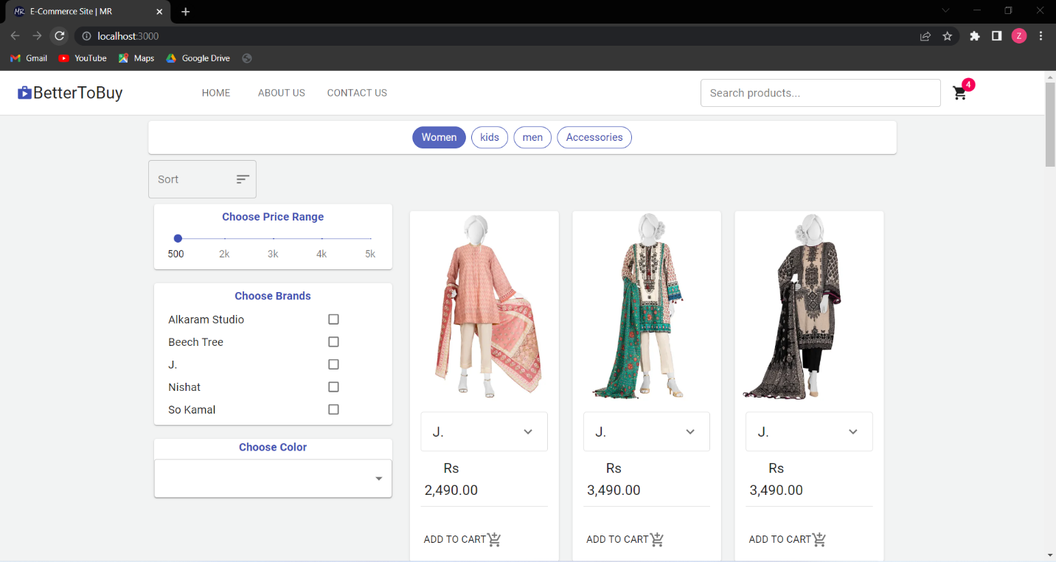

Figure 3.7.1: Home Page

### Apply Price Filter

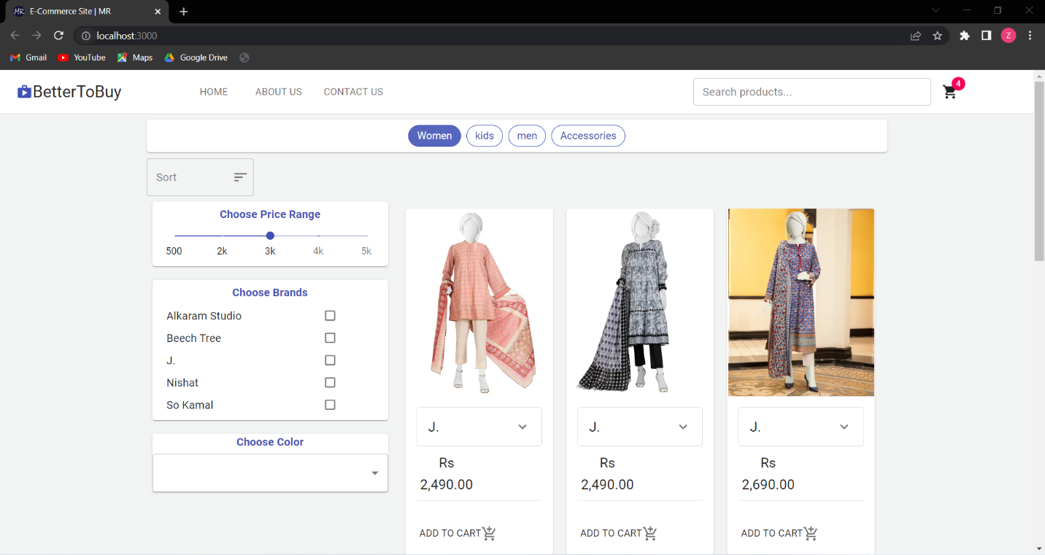

Figure 3.7.2: Apply Price Filter

### Apply Brand Filter

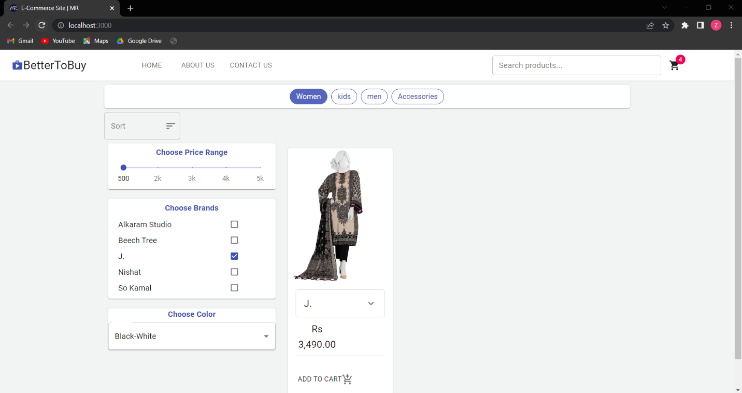Figure 3.7.3: Apply Brand Filter

### About Us

Figure 3.7.4: About Us

### Contact Us

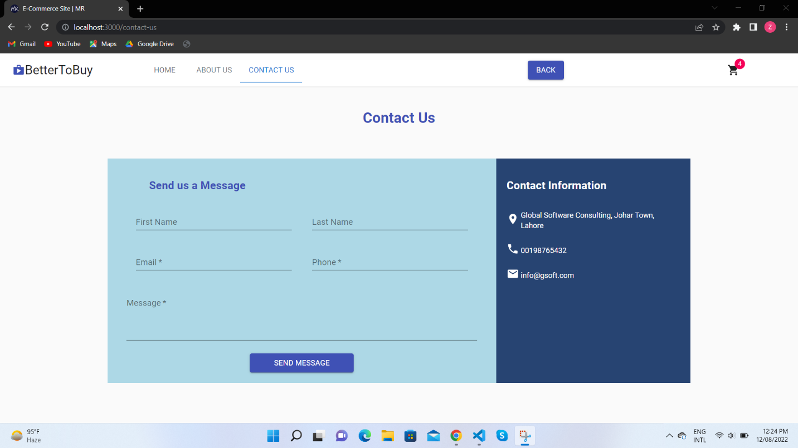

### Figure 3.7.5: Contact Us

### Add to Cart

Figure 3.7.6: Add to Cart

### Billing Information

### Figure 3.7.7: Billing Information

### C:\Users\Zuha\OneDrive\Desktop\P4.pngReview and Confirmation

Figure 3.7.8: Review and Confirmation

### Order CompletionC:\Users\Zuha\OneDrive\Desktop\P5.png

Figure3.7.9: Order Completion

### Remove Item from Cart

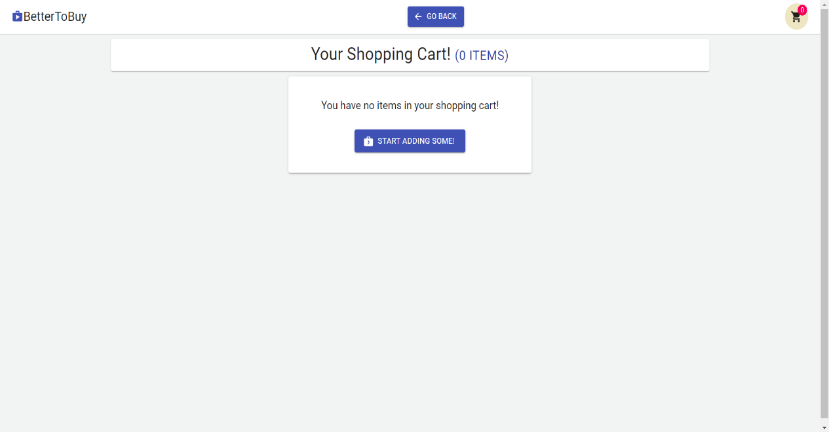

Figure 3.7.10: Remove Item from Cart

# **Data Flow Diagram(Optional)**

## Data Flow Diagram Level 0

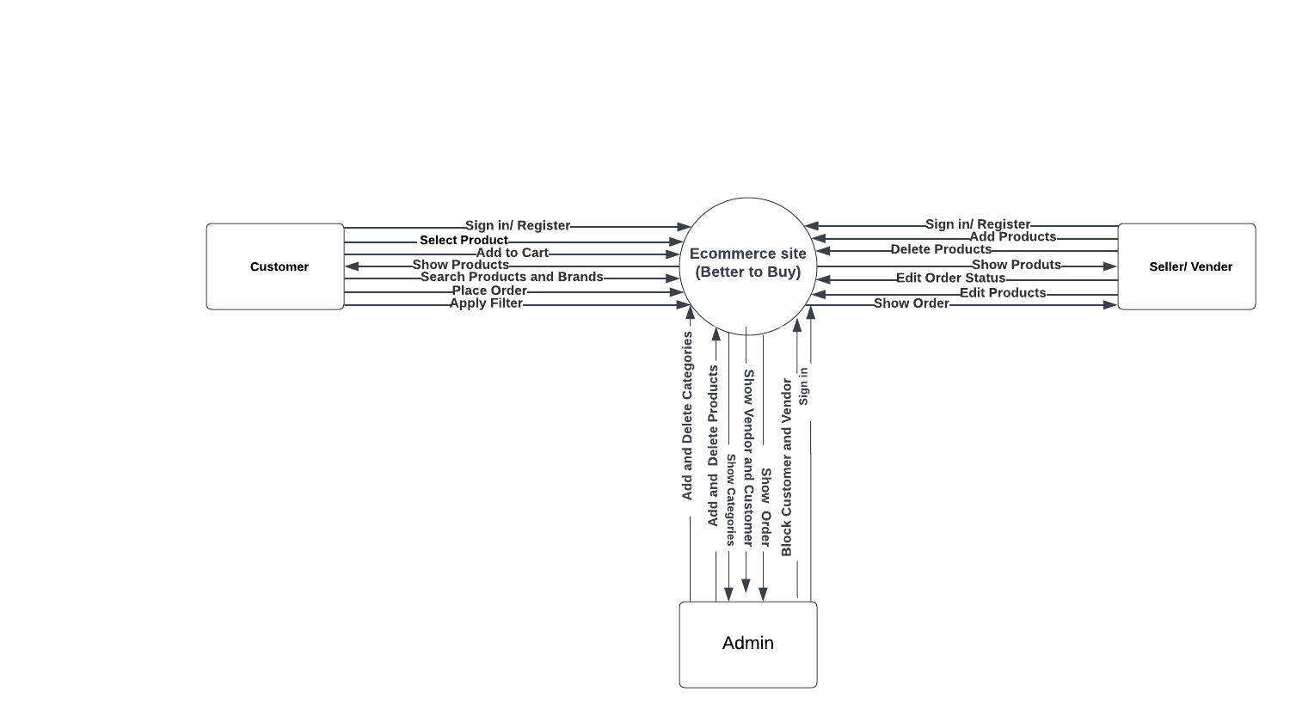

Figure 4.1.1: DFD 0

# **System Design**

## System Architecture Diagram

### Context Diagram

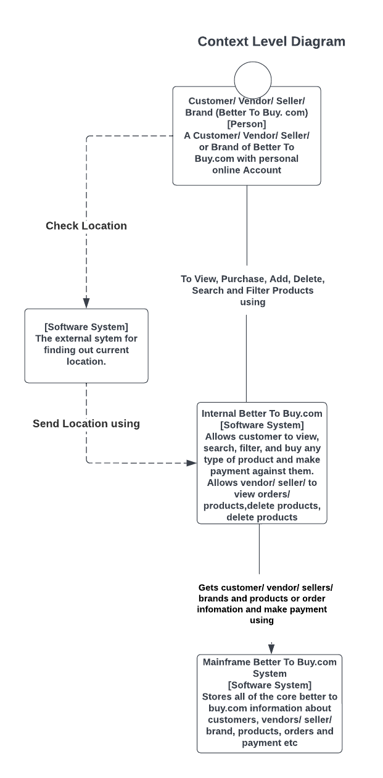

Figure 5.1.1: Context Diagram

## Class Diagram

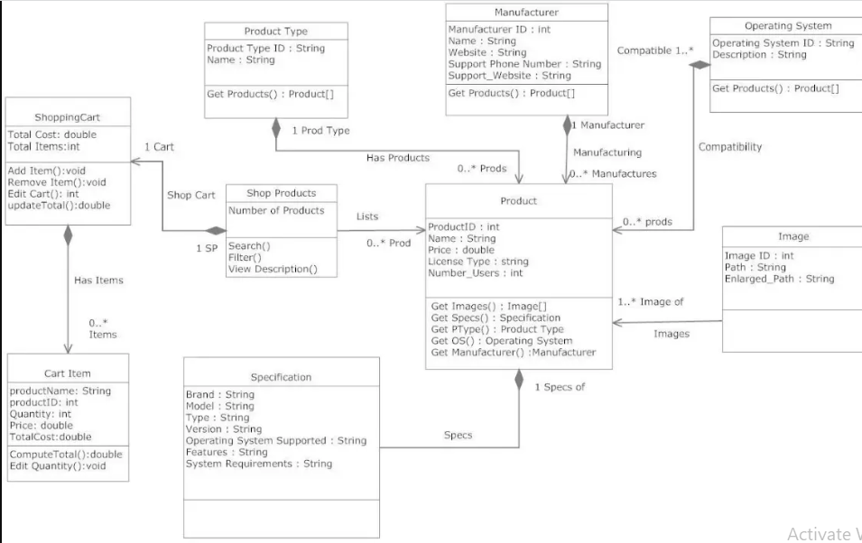

Figure 5.2.1: Class Diagram

## Sequence Diagram

## 5.3.1 Sequence Diagram Sign up

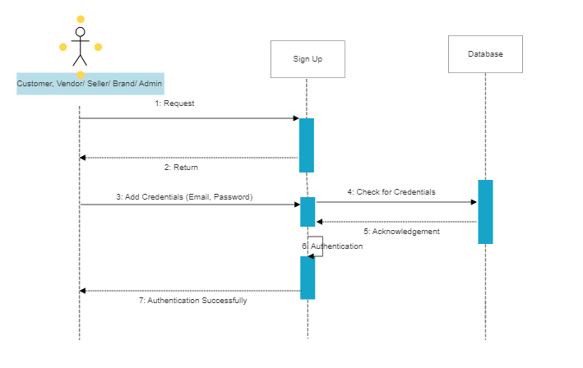

Figure 5.3.1: Sequence Diagram Sign up

## 5.3.2 Sequence Diagram Sign in

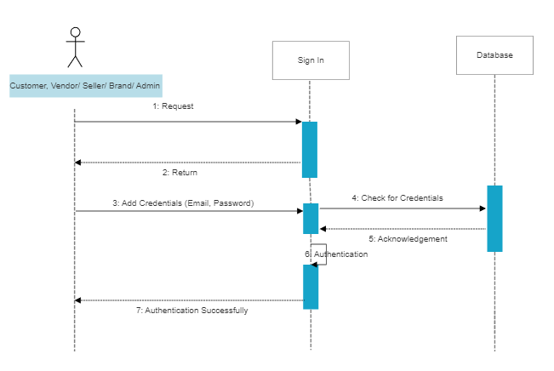

Figure 5.3.2: Sequence Diagram Sign in

### 5.3.3: Sequence Diagram View Product

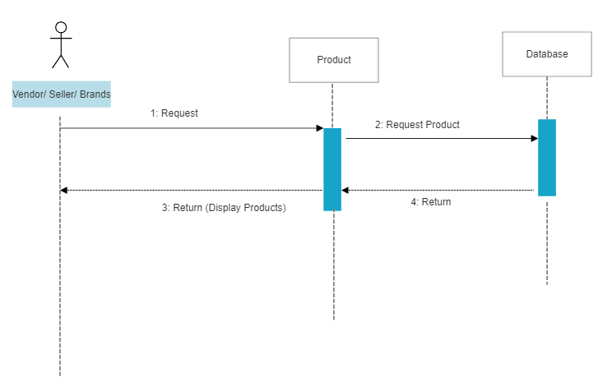

Figure 5.3.3: Sequence Diagram View Product

## 5.3.4: Sequence Diagram Add Product

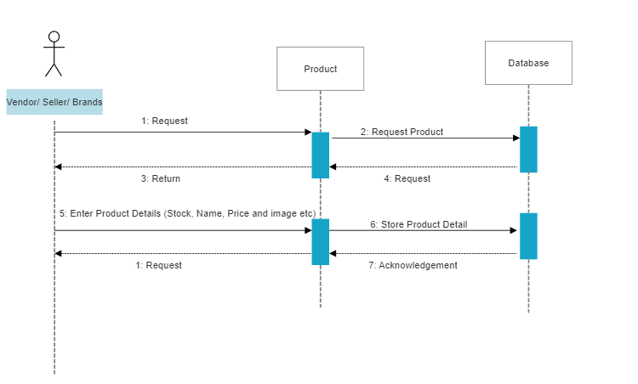

Figure 5.3.4: Sequence Diagram Add Product

## 5.3.5: Sequence Diagram View Category

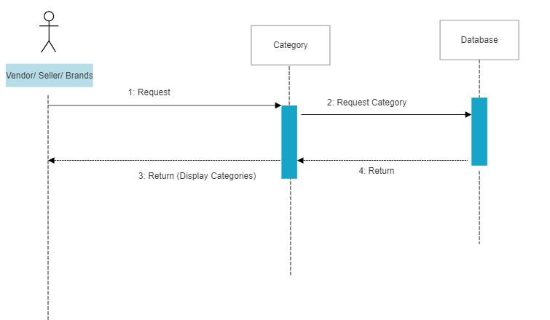

Figure 5.3.5: Sequence Diagram View Category

## 5.3.6: Sequence Diagram Add Category

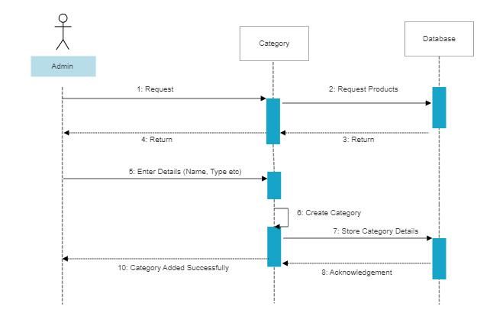

Figure 5.3.6: Sequence Diagram Add Category

## 5.3.7: Sequence Diagram Delete Category

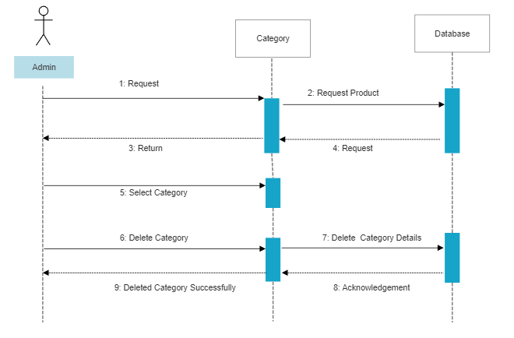

Figure 5.3.7: Sequence Diagram Delete Category

## 5.3.8: Sequence Diagram Show Filter Products

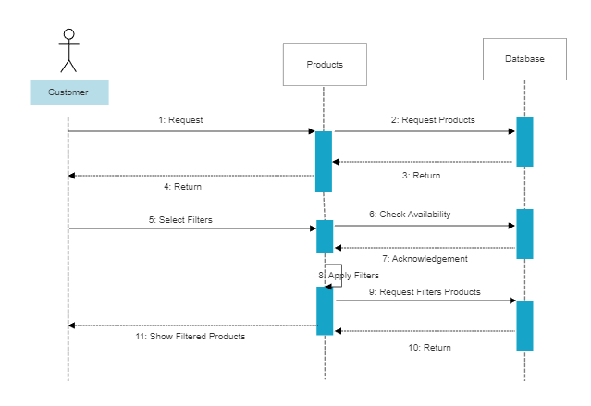

Figure 5.3.8: Sequence Diagram Show Filter Products

## 5.3.9: Sequence Diagram Add Discount

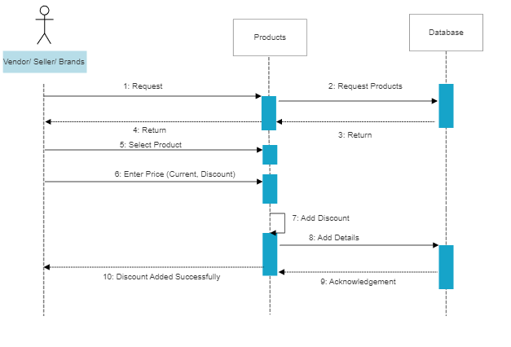

Figure 5.3.9: Sequence Diagram Add Discount

## 5.3.10: Sequence Diagram Payment

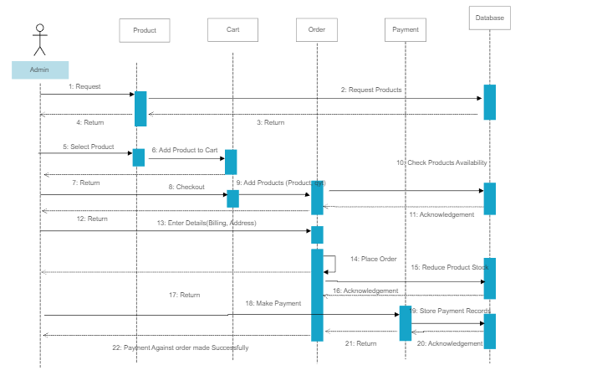

Figure 5.3.10: Sequence Diagram Payment

## 5.3.11: Sequence Diagram Billing Detail

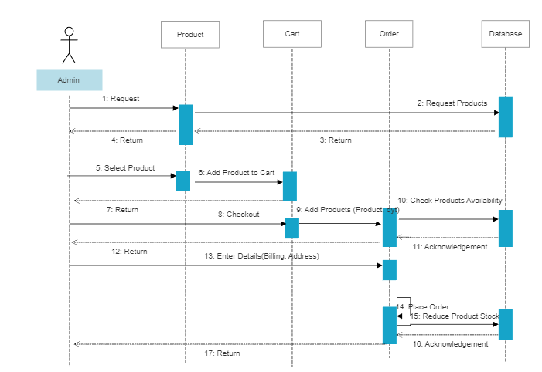

Figure 5.3.11: Sequence Diagram Billing Detail

## Collaboration Diagrams

## 5.4.1: Collaboration Diagram Sign up

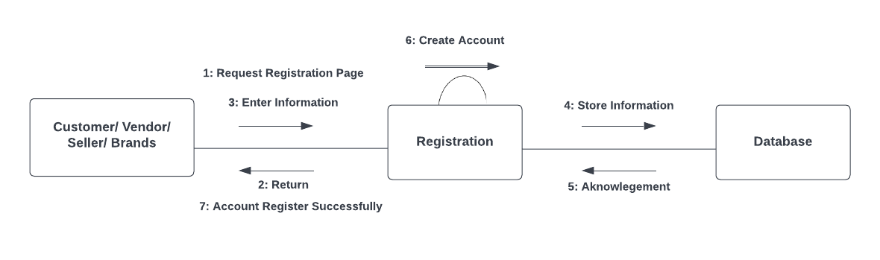

Figure 5.4.1: Collaboration Diagram Sign up

## 5.4.2: Collaboration Diagram Sign in

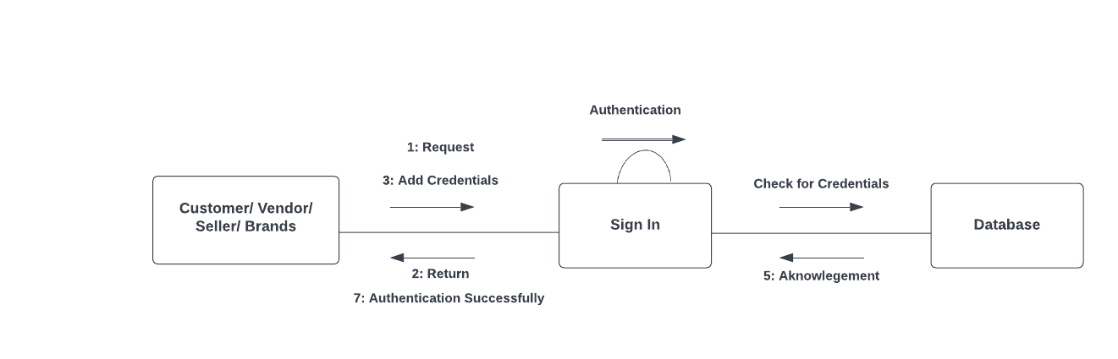

Figure 5.4.2: Collaboration Diagram Sign in

## 5.4.3: Collaboration Diagram Add Product

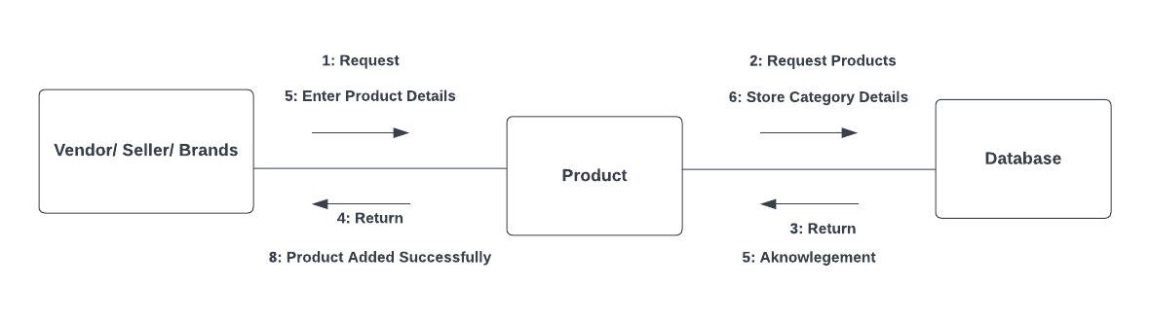

Figure 5.4.3: Collaboration Diagram Add Product

## 5.4.4: Collaboration Diagram Apply Filter

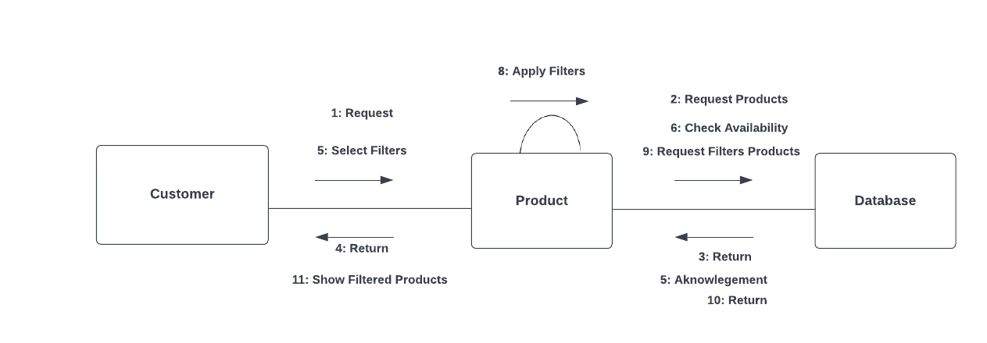

Figure 5.4.4: Collaboration Diagram Apply Filter

## 5.4.5: Collaboration Diagram View Product

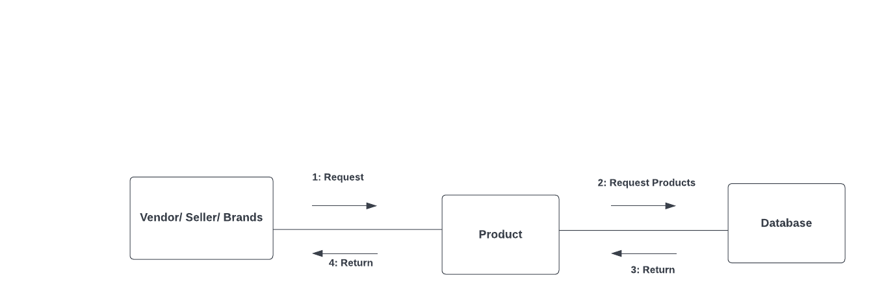

Figure 5.4.5: Collaboration Diagram View Product

## 5.4.6: Collaboration Diagram View Category

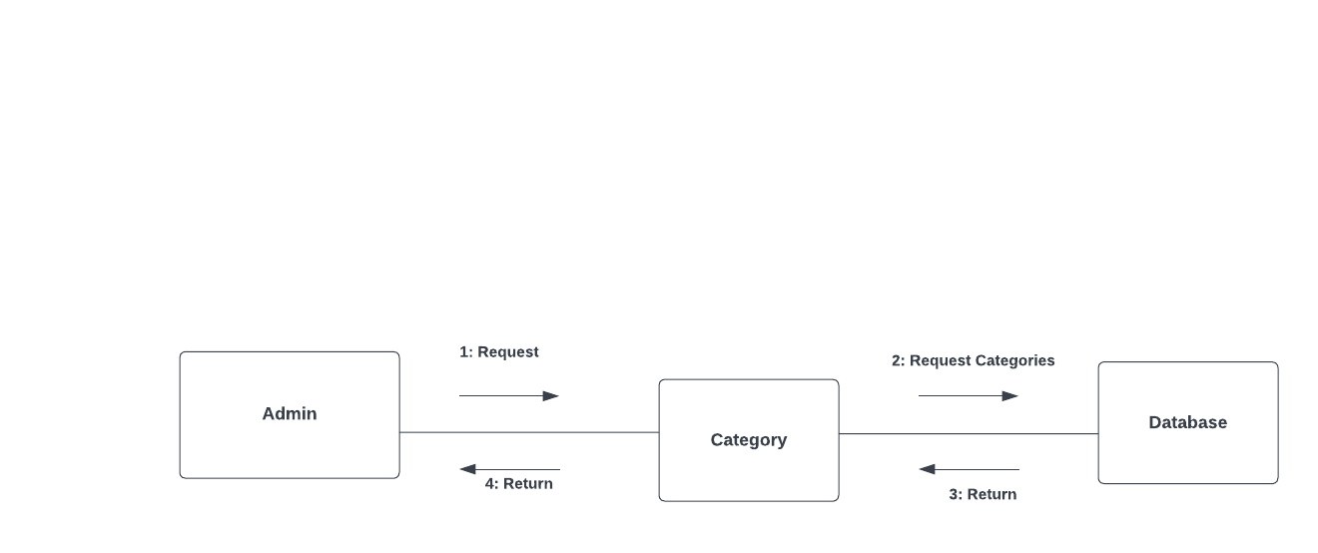

Figure 5.4.6: Collaboration Diagram View Category

## 5.4.7: Collaboration Diagram Delete Category

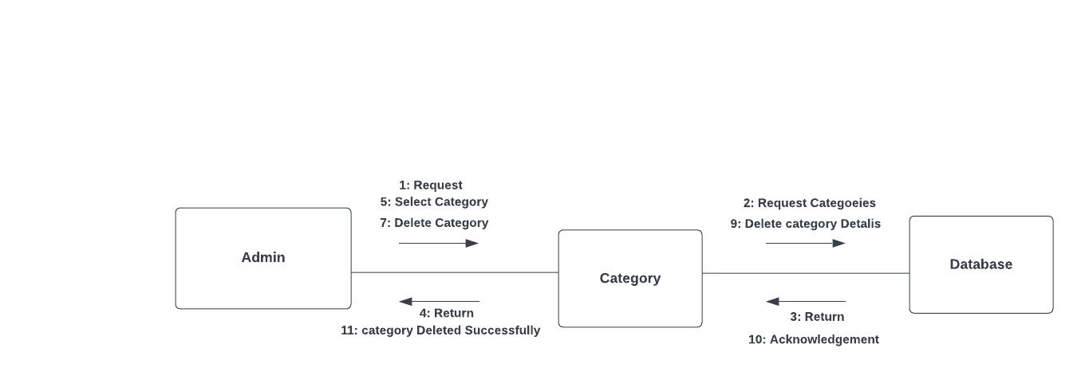

Figure 5.4.7: Collaboration Diagram Delete Category

## ERD

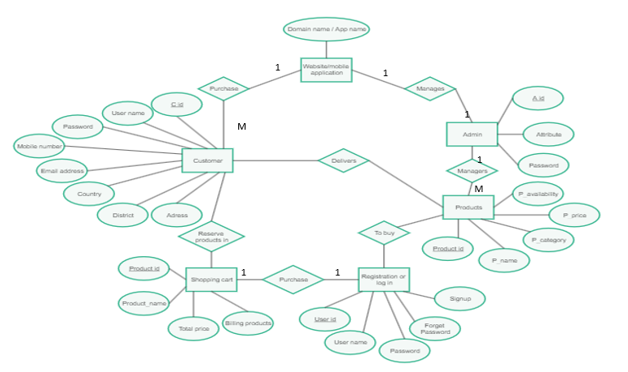

Figure 5.5.1: ERD

# **Implementation Details:**

## Development Setup:

Table 6.1.1: Development Setup

|  |  |
| --- | --- |
| **Tools/ Techniques** | **Description** |
| HTML5/ CSS3 | Used for frontend designing. |
| SASS | Used for style sheets. |
| React JS | Used for frontend development. |
| Node JS | Used for backend development. |
| Strapi | Used to make data structure. |
| Mongo DB | Used to save data in database. |

## Deployment Setup:

System is currently running on local host.

## Constraints:

### Assumptions:

The assumptions that will be true while using this system are:

* User should have a working internet connection while using this app.
* Admin will be able to make changes in the system.

### System Constraints:

No extra constraints are implemented on the system. The important contraints are already mentioned in requirements.

### Restrictions:

No restrictions are imposed on the user.

### Limitations:

The following are some restrictions imposed on the system:

* System should only be usable with the availability of a good internet connection.
* The speed of internet for using this system should be 60 Mbps.

# **Testing**

## Test Cases:

Table 7.1.1: Test Case 1 Sign Up

|  |  |  |  |  |
| --- | --- | --- | --- | --- |
| **Test case ID:** | | TC-01 | **Test Design By:** | Zuha Urooj |
| **Test Module Name:** | | Sign Up | **Test Design Date:** | 7th July, 2022. |
| **Test Priority:** | | High | **Test Executed By:** | Anam Asghar |
| **Test Name:** | | Create an Account | **Test Executed Date:** | 8th July, 2022. |
| **Description:** | | Check seller and buyers details based on valid data. | | |
| **Pre-Condition:** | | 1. User should have valid email id.  2. User should be on the registration page. | | |
| **Dependencies:** User should have valid email id. | | | | |
| **Step** | **Test Step** | | **Test Data** | |
|  | Go to the website (Better To Buy). | |  | |
|  | Click on Sign Up. | |  | |
|  | Fill the registration form. | |  | |
|  | Enter Full Name. | | Zuha Urooj | |
|  | Enter Email Address. | | f2018105017@umt.edu.pk | |
|  | Enter Phone Number. | | 03086223943 | |
|  | Enter Address. | | Wapda Town, Lahore. | |
|  | Enter Password. | | 0000 | |
|  | Enter Confirm Password. | | 0000 | |
|  | Hit Sign Up. | |  | |
| **Expected Result:** | | Seller/ Buyer should be able to register account. | | |
| **Actual Result:** | | Seller/ Buyer successfully registered account. | | |
| **Status:** | | Pass | | |
| **Post Condition:** | | 1. Request for sign up is stored in system. 2. System display message: Account has been created successfully. | | |

Table 7.1.2: Test Case 2 Sign In

|  |  |  |  |  |
| --- | --- | --- | --- | --- |
| **Test case ID:** | | TC-02 | **Test Design By:** | Zuha Urooj |
| **Test Module Name:** | | Sign In | **Test Design Date:** | 7th July, 2022. |
| **Test Priority:** | | High | **Test Executed By:** | Anam Asghar |
| **Test Name:** | | Login to Account | **Test Executed Date:** | 8th July, 2022. |
| **Description:** | | Buyers/ Sellers should be verified by valid data. | | |
| **Pre-Condition:** | | 1. User should have an account.  2. User should be on the login page. | | |
| **Dependencies:** User should have account on this site. | | | | |
| **Step** | **Test Step** | | **Test Data** | |
| **1.** | Go to the website (Better To Buy). | |  | |
| **2.** | Click on Sign In. | |  | |
| **3.** | Fill the login form. | |  | |
| **4.** | Enter Full Name. | | Zuha Urooj | |
| **5.** | Enter Password. | | 0000 | |
| **6.** | Hit Sign In. | |  | |
| **Expected Result:** | | Seller/ Buyer should be able to login. | | |
| **Actual Result:** | | Seller/ Buyer successfully logged in. | | |
| **Status:** | | Pass | | |
| **Post Condition:** | | 1. Request for sign in is stored in system. 2. System has signed in for authentication. | | |

Table 7.1.3: Test Case 3 Select Product

|  |  |  |  |  |
| --- | --- | --- | --- | --- |
| **Test case ID:** | | TC-03 | **Test Design By:** | Zuha Urooj |
| **Test Module Name:** | | Select Product | **Test Design Date:** | 7th July, 2022. |
| **Test Priority:** | | High | **Test Executed By:** | Anam Asghar |
| **Test Name:** | | Select Product from the system. | **Test Executed Date:** | 8th July, 2022. |
| **Description:** | | User should be able to select product from the system. | | |
| **Pre-Condition:** | | 1. User should have account.  2. User should be on the product page. | | |
| **Dependencies:** User should have valid email id. | | | | |
| **Step** | **Test Step** | | **Test Data** | |
| **1.** | Go to the home page of Better To Buy. | |  | |
| **2.** | Select product from there. | |  | |
| **Expected Result:** | | User should be able to select product. | | |
| **Actual Result:** | | Product should be selected successfully. | | |
| **Status:** | | Pass | | |
| **Post Condition:** | | 1. Request for select product is stored in system. 2. Product should be selected successfully. | | |

Table7.1.4: Test Case 4 Add to Cart

|  |  |  |  |  |
| --- | --- | --- | --- | --- |
| **Test case ID:** | | TC-04 | **Test Design By:** | Zuha Urooj |
| **Test Module Name:** | | Add to Cart | **Test Design Date:** | 7 July, 2022. |
| **Test Priority:** | | High | **Test Executed By:** | Anam Asghar |
| **Test Name:** | | Adding products to cart. | **Test Executed Date:** | 8 July, 2022. |
| **Description:** | | Check, Vendor/Seller should be able to add products into the cart. | | |
| **Pre-Condition:** | | 1. User should be on the product card. 2. User should be on Add to Cart button. | | |
| **Dependencies:** User should have valid items to enter in cart. | | | | |
| **Step** | **Test Step** | | **Test Data** | |
|  | Go to homepage. | |  | |
|  | Click on Add to Cart. | |  | |
|  | Click on checkout. | |  | |
| **Expected Result:** | | Buyer should be able to add product to cart. | | |
| **Actual Result:** | | Products add successfully into the cart. | | |
| **Status:** | | Pass | | |
| **Post Condition:** | | 1. Request for add product to cart is stored in system. 2. System will add the product in cart. | | |

Table 7.1.5: Test Case 5 Place an Order

|  |  |  |  |  |
| --- | --- | --- | --- | --- |
| **Test case ID:** | | TC-05 | **Test Design By:** | Zuha Urooj |
| **Test Module Name:** | | Place an Order | **Test Design Date:** | 7 July, 2022. |
| **Test Priority:** | | High | **Test Executed By:** | Anam Asghar |
| **Test Name:** | | Place order for products. | **Test Executed Date:** | 8 July, 2022. |
| **Description:** | | Check order placing of available products. | | |
| **Pre-Condition:** | | 1. Customer should select the product. 2. Product should be added to the cart. 3. Product should be available in stock. | | |
| **Dependencies:** Product should be added to the cart and available in stock. | | | | |
| **Step** | **Test Step** | | **Test Data** | |
|  | Click on checkout button. | |  | |
|  | Enter personal Information. | |  | |
|  | Enter Name | | Zuha Urooj | |
|  | Enter Email | | f2018105017@umt.edu.pk | |
|  | Enter Billing Details | | COD | |
|  | Select Delivery/Pickup | | Any | |
|  | Enter Full Name | | Zuha Urooj | |
|  | Enter Email Address | | f2018105017@umt.edu.pk | |
|  | Enter Phone Number | | 03083290930 | |
|  | Enter Address | | Wapda Town, Lahore | |
|  | Select Country | | Pakistan | |
|  | Enter City | | Lahore | |
|  | Enter Postal Code | | 54000 | |
|  | Click on Continue | |  | |
| **Expected Result:** | | Customer should be able to place order. | | |
| **Actual Result:** | | Customer successfully placed order. | | |
| **Status:** | | Pass | | |
| **Post Condition:** | | 1. Request for place an order is stored in system. 2. System should display payment page. | | |

Table 7.1.6: Test Case 6 Apply Filters

|  |  |  |  |  |
| --- | --- | --- | --- | --- |
| **Test case ID:** | | TC-06 | **Test Design By:** | Zuha Urooj |
| **Test Module Name:** | | Applying Filters | **Test Design Date:** | 7 July, 2022. |
| **Test Priority:** | | High | **Test Executed By:** | Anam Asghar |
| **Test Name:** | | Applying Filter on Products | **Test Executed Date:** | 8 July, 2022. |
| **Description:** | | Apply valid Filter on the products. | | |
| **Pre-Condition:** | | 1. Products should be available or in stock. 2. Customer should select any category. 3. Customer should be on any category page. | | |
| **Dependencies:** Products should be available or in stock. | | | | |
| **Step** | **Test Step** | | **Test Data** | |
|  | Go to Better to Buy. | |  | |
|  | Click on any Category. | |  | |
|  | Select Filter. | |  | |
|  | Select Filter by Brand. | | Alkaram | |
|  | Select Filter by Price. | | 3000 | |
|  | Select Filter by Color. | | Black | |
| **Expected Result:** | | System should be able to apply filter. | | |
| **Actual Result:** | | Filter on products successfully applied. | | |
| **Status:** | | Pass | | |
| **Post Condition:** | | 1. Request for apply filters is stored in system. 2. System show the products with selected filters. | | |

Table 7.1.7: Test Case 7 Add Product

|  |  |  |  |  |
| --- | --- | --- | --- | --- |
| **Test case ID:** | | TC-07 | **Test Design By:** | Zuha Urooj |
| **Test Module Name:** | | Add Products. | **Test Design Date:** | 7 July, 2022 |
| **Test Priority:** | | High | **Test Executed By:** | Anam Asghar |
| **Test Name:** | | Adding products to cart. | **Test Executed Date:** | 8 July, 2022 |
| **Description:** | | Check, Vendor/Seller should be able to add grocery products into the System. | | |
| **Pre-Condition:** | | 1. Vendor/Seller should have a valid account. 2. Vendor/Seller should be Sign In into account. 3. Vendor/Seller should be on Add New Product Page. | | |
| **Dependencies:** Vendor/Seller should have active and valid account. | | | | |
| **Step** | **Test Step** | | **Test Data** | |
| **1.** | Go to vendor/seller dashboard. | |  | |
| **2.** | Click on Add Product. | |  | |
| **3.** | Enter Product Name. | | Two Piece | |
|  | Select Category. | | Women | |
|  | Select Sub Category. | | Unstiched | |
|  | Enter Product Stock. | | 20 | |
|  | Enter Product Description. | |  | |
|  | Enter Product Price. | | 2800 | |
|  | Click on Add Product. | |  | |
| **Expected Result:** | | Vendor/Seller should be able to add product into the System. | | |
| **Actual Result:** | | Products add successfully into the system. | | |
| **Status:** | | Pass | | |
| **Post Condition:** | | 1. Request for add product is stored in system. 2. System will add the product in product list. | | |

Table 7.1.8: Test Case 8 Add Category

|  |  |  |  |  |
| --- | --- | --- | --- | --- |
| **Test case ID:** | | TC-08 | **Test Design By:** | Zuha Urooj |
| **Test Module Name:** | | Add Category. | **Test Design Date:** | 7 July, 2022 |
| **Test Priority:** | | High | **Test Executed By:** | Anam Asghar |
| **Test Name:** | | Add Category into the System. | **Test Executed Date:** | 8 July, 2022 |
| **Description:** | | Check, Admin should be able to add category into the system. | | |
| **Pre-Condition:** | | 1. Admin should have an account. 2. Admin should be Sign In into account. 3. Admin should be on Add New Category Page. | | |
| **Dependencies:** Admin should have an account and should be on Add New Category Page. | | | | |
| **Step** | **Test Step** | | **Test Data** | |
|  | Go to Manage Categories. | |  | |
|  | Click on Main Category. | |  | |
|  | Click on Add New Category. | |  | |
|  | Enter Category Name. | | Women | |
|  | Click on Create Category Button. | |  | |
| **Expected Result:** | | Admin should be able to Add New Category into the System. | | |
| **Actual Result:** | | New Category Added into the system successfully. | | |
| **Status:** | | Pass | | |
| **Post Condition:** | | 1. Request for add Category is stored in system. 2. System will add the Category in Category list. | | |

Table 7.1.9: Test Case 9 Delete Category

|  |  |  |  |  |
| --- | --- | --- | --- | --- |
| **Test case ID:** | | TC-09 | **Test Design By:** | Zuha Urooj |
| **Test Module Name:** | | Delete Category. | **Test Design Date:** | 7 July, 2022 |
| **Test Priority:** | | Medium | **Test Executed By:** | Anam Asghar |
| **Test Name:** | | Delete Category from the System. | **Test Executed Date:** | 8 July, 2022 |
| **Description:** | | Check, admin should be able to Delete Category from the system. | | |
| **Pre-Condition:** | | 1. Admin should have an account. 2. Admin should be Sign In into account. 3. Admin should be on Delete Category Page. | | |
| **Dependencies:** Admin should have an account and should be on Delete Category Page. | | | | |
| **Step** | **Test Step** | | **Test Data** | |
|  | Go to Manage Categories. | |  | |
|  | Click on Main Category. | |  | |
|  | Select Category. | | Women | |
|  | Click on Delete Category. | |  | |
|  | Click on register button. | |  | |
| **Expected Result:** | | Admin should be able to Delete Product from the System. | | |
| **Actual Result:** | | Product Deleted from the System successfully. | | |
| **Status:** | | Pass | | |
| **Post Condition:** | | 1. Request for delete Category is stored in system. 2. System will delete the Category from the Category list. | | |

Table 7.1.10: Test Case 10 View Category

|  |  |  |  |  |
| --- | --- | --- | --- | --- |
| **Test case ID:** | | TC-10 | **Test Design By:** | Zuha Urooj |
| **Test Module Name:** | | View Category. | **Test Design Date:** | 7 July, 2022 |
| **Test Priority:** | | Medium | **Test Executed By:** | Anam Asghar |
| **Test Name:** | | View Category in the System. | **Test Executed Date:** | 8 July, 2022 |
| **Description:** | | Check, Admin should be able to View Category in the System. | | |
| **Pre-Condition:** | | 1. Admin should have an account. 2. Admin should be Sign In into account. 3. Admin should be on View Category Page. | | |
| **Dependencies:** Admin should have an account and should be on View Category Page. | | | | |
| **Step** | **Test Step** | | **Test Data** | |
|  | Go to Admin Dashboard. | |  | |
|  | Go to Manage Categories. | |  | |
|  | Click on Main Category. | |  | |
| **Expected Result:** | | Admin should be able to View Category from the Category List. | | |
| **Actual Result:** | | Categories should be displayed to Admin successfully. | | |
| **Status:** | | Pass | | |
| **Post Condition:** | | 1. Request for view Category is stored in system. 2. System will view the Category from the Category list. | | |

Table 7.1.11: Test Case 11 View Product

|  |  |  |  |  |
| --- | --- | --- | --- | --- |
| **Test case ID:** | | TC-11 | **Test Design By:** | Zuha Urooj |
| **Test Module Name:** | | View Product. | **Test Design Date:** | 7 July, 2022 |
| **Test Priority:** | | High | **Test Executed By:** | Anam Asghar |
| **Test Name:** | | View Product from the System. | **Test Executed Date:** | 8 July, 2022 |
| **Description:** | | User should be able to view available products in the System. | | |
| **Pre-Condition:** | | 1. User should have an account. 2. User should be Sign In into account. 3. User should be on View Product Page. | | |
| **Dependencies:** Customer should have valid email ID. | | | | |
| **Step** | **Test Step** | | **Test Data** | |
|  | Go to Vendor/Seller Dashboard. | |  | |
|  | Click on View Products. | |  | |
| **Expected Result:** | | User should be able to view products. | | |
| **Actual Result:** | | Products should be displayed to the user successfully. | | |
| **Status:** | | Pass | | |
| **Post Condition:** | | 1. Request for view Product is stored in system. 2. System will view the Product from the Product list. | | |

# **Results/Outputs/Statistics:**

## % Completion

98 % completion.

## % Accuracy

98% accuracy

## % Correctness

96% correctness.

# **Conclusion:**

It is an E-commerce platform for the customers and sellers on where they can sell and buy clothing products. It helps the customer to place order from any of there favorite brandsor help them to find their product.As people are busy in their lives, don’t have that much time to go to the store to purchase it or some time that product is not available in such store and even now during COVID, people must follow the SOPs to keep themselves as well as their loved ones safe. During such situation customers have go through difficult process while purchasing products physically. So, this platform will help them to still purchase their products online or place order to pick it up from store while keeping, the safety of the seller as well as customers, in mind. We aim to cater maximum of audience both seller and buyer to save their time and increase in their business.

# **Future Work:**

In future we will add more features in our system depending upon the requirements of the users. Other than that, we will add other things beyond women clothing and recommendation system. This will be helpful for the users. We also have further plans to deploy our project in future.

# **Bibliography:**

## Books:

* Anne Boehm, Joel Murach, Murach’s ASP.NET 4 Web Programming with C# 2010, 4th Edition, Murach, 2010.
* Bryan Syverson, Joel Murach, Murach’s SQL Server 2012 for developers, Murach, 2012.

## Journals:

* Babin, B.J., Darden, W.R and Griffin M (1994), “Work and /or fun; measuring hedonic and utilitarian shopping value, “Journal of consumer Research, Vol. 20, pp 644-656.
* Childers, T.L., Carr, C.L. Peck, J and Carson, S (2001), “Hedonic and utilitarian motivations for online retail shopping behavior”, Journal of Retailing, Vol. 77, No. 4. pp. 511-535.
* Hirschman, E.C. and Holbrook, M.B. (1982), “Hedonic Consumption; emerging concepts, methods and proportions”, Journal of marketing, Vol: 48, No. 3, pp 92-101.

## Other References:

* <https://nodejs.dev/learn>
* <https://www.npmjs.com/package/cheerio>
* <https://docs.strapi.io/developer-docs/latest/getting-started/introduction.html#open-source-contribution>
* <https://www.w3schools.com/>
* <https://stackoverflow.com/>
* <https://github.com/>

# **Appendix:**

## Glossary of Terms:

None.

## Pre-Requisites**:**

You should have the knowledge about Web Technologies and postgres database before developing this application.